2023
Internal Audit Department
Khalifa University of Science and Technology
June - 2023


Internal Audit Report
Business Development

Ref: KU/2023/IAD-XXX
July 2023

Jalal Jazzar
Khalifa University of Science and Technology

We have completed our review of Business Development. The review was conducted during May – June 2023 covering the period from January 2022 to December 2022.

The objective of our audit was to review the adequacy and effectiveness of internal controls system and procedures; and to ensure compliance with operating policies and procedures, laws and regulations.

We have discussed the contents of our report, including our recommendations, with the respective processes’ owners and where relevant we have incorporated their comments and action plans to remediate our findings.

I would like to draw your attention to the issues highlighted in the executive summary, where opportunities for improvement were highlighted.

Yours Sincerely,

Abdulaziz Alkhoori
VP, Audit

Table of Contents

1. Executive Summary 4
1.1 Introduction 4
1.2 Scope of Work 4
1.3 Audit Objectives 4
1.4 Audit Process 4
2. Summary of Audit Findings 4
3. Background 5
4. Detailed Audit Findings 6
5. Appendix 11

- Executive Summary
  - Introduction
We have completed the Review of Business Development, in line with the Approved Internal Audit Plan and Scope Letter Dated May 2023. The Internal Audit Findings / Improvement Opportunities to address associated risks / control gaps were identified and reported as part of this report.
  - Scope of Work
The Scope of Work comprised of the following areas:
- Governance and Compliance.
- Operations.
- Budget and Other Finance related.
  - Audit Objectives
The Objective of this review is to provide independent and objective assessments of KU’s business processes and systems of risk management, internal controls and governance processes. Further, assess compliance with policies/procedures and efficiency and effectiveness of operations and resource utilization.
  - Audit Process
The following are the key Audit Steps undertaken by the IA Department:
- Gain an understanding of the processes of the areas covered in the scope listed above.
- Reviewed adequacy and effectiveness of internal controls system and procedures.
- Reviewed compliance with the policies and procedures, laws and regulations.
- Agreed with process owners on action plans to improve control effectiveness / process performance.
- Summary of Audit Findings
Controls need to be enhanced for XX% of the observations. A balance of XX% is within the moderate range and needs to be monitored and prevented from entering the high-risk category and moderate range as applicable.

Please refer to Appendix – 1 for detailed Ratings
The audit findings found during the review are summarized below. It should be noted that we have reported only on the exceptions detected during the course of our review.
- XXXX
- To be updated once finalized
- XXXXX
- To be updated once finalized

- Background
The Business Development (BD) unit at Khalifa University was set up in 2017. As part of the KU drive for sustainability and revenue growth, the BD Function was set up as a means through which funds could be generated for the university, to supplement existing grant funding, with the overall goal of ensuring the long-term sustainability of the university.
The Business Development unit facilitates a range of business services in areas such as consultancy services, laboratory rental, sports facilities, and venue rental etc.
- Business Inquiries
Business Development inquiries such as venue rental, sports facility rental can inquired through Business Development webpage on KU Website by filling a form or by contacting directly at Businessdevelopment@ku.ac.ae.
- Strategic Goals and Objectives
Business Development department is currently in the process of finalizing its vision, mission, Policies and procedures.
- Periodic Reporting
Periodic consolidated reporting is submitted to KU Management including the following:
- Revenue budget vs actuals;
- Projects in progress by Academics, Facilities or Investment;
- Other details as deemed necessary.
- Business Development Budget
Separate Budget (operational or capex) is not estimated for the BD Department. As a result, no budget code has been established for the BD Function. Add which budget codes are currently in use.
- Key Performance Indicators
Staff Key performance indicators are set and monitored on periodic basis. However, Departmental Key Performance Indicators are yet to be established including and short and Long Terms Goals which align with KU Strategic Objectives and Initiatives. Add on what basis the function is being monitored and measured now.
- Revenue Income Streams
Following are broader categories of Revenue streams at KU:
- Facilities:
  - Space Rental
  - Outlet Rental
  - Sports Rental
  - Student Services (Cards, Certificates etc.)
  - Laboratory services
  - Dorms / Accommodation
  - Transportation
- Academic
  - Scholarship (Tuition)
  - Sponsorship
  - Continuing Education Center
- Investment
  - Techno Park
  - Endowment
  - KUEC

- Detailed Audit Findings
● High | - Strategic Direction & Progress
Risk Ref : KU-BD-01, KU-BD-02
Observation/Process Enhancement
Our review of Business Development (BD) Scope briefing document developed in 2017 showed:
- Absence of approved Strategy documenting vision, mission and strategic objectives.
As a result, there is no formal approved document currently available which shows departments’ alignment with the previous KU Strategic Plan 2017 – 2022 or current KU Strategic Plan 2021 – 2031 i.e. how BD department contributes overall KU Strategic initiatives and objectives. The department is currently working towards developing strategy, vision and mission.
Further, in absence of approved strategy, BD scope of work is unclear i.e. whether BD facilitates business services or is responsible entirely for certain business services revenue generation.
Year | Approved Budget | Actual
2019 | 134,724,000 | 59,930,967
2020 | 63,141,000 | 58,259,930
2021 | 49,095,000 | 36,862,523
2022 | 66,229,000 | 51,338,686
- In addition, review of revenue actuals across KU over the course of 4 years (2019 – 2022) showed that KU revenue generation has decreased and revenue budget was not achieved either.
Please refer to details in the table and infographics below:

Recommendations
- Establish BD Strategy and obtain approvals as per the DoA.
- Ensure BD Strategy is aligned with KU Strategic Initiatives and Objectives.
Management Action Plan
Management Action Plan:
XX
Responsibility:
XX
Timelines:
XX
● High | - Governance – Policy and Procedures
Risk Ref : KU-BD-07
Observation/Process Enhancement
Policies and procedures provide clear guidelines and instructions ensuring consistent and effective decision-making. Without established governance policies, there is a lack of direction, accountability, and transparency in the BD activities. Our review of the BD Department noted absence of formally developed Policy and Procedures such as:
- Lead Generation and Sales Pipeline Management / Inquiry Management;
- Contract and Proposal Management;
- Performance Measurement and reporting;
- Pricing and Costing;
- Investment Placing;
- Project Management etc.
Recommendation
- Establish comprehensive policies and procedure covering the entire activities undertaken by BD.
- Ensure adequate implementation and compliance with policies and procedures.
Management Action Plan
Management Action Plan:
XX
Responsibility:
XX
Timelines:
XX
● Medium | - Key Performance Indicators (KPI’s)
Risk Ref : KU-BD-09
Observation/Process Enhancement
Although, BD Staff KPI’s are set and monitored, our review of BD Department noted absence of short term and Long term plan with formally developed KPI’s to monitor and periodically report on the progress against set targets.
As a result, there is no formal mechanism to gauge / track progress against targets of the department, provide a focus for strategic and operational improvement, create an analytical basis for decision making and help focus attention towards BD Vision and Objectives particularly when revenue generation has decreased over the past 4 years (Refer finding 01).
Recommendation
- Establish Short Term and Long Term plan to execute BD Strategy.
- Establish Short Term and Long Term Key Performance Indicators.
- Periodically monitor and report on status of KPIs to KU Management.
Management Action Plan
Management Action Plan:
xx
Responsibility:
xx
Timelines:
Xx
● High | - Reporting
Risk Ref : KU-BD-05
Observation/Process Enhancement
Revenue
Although BD Department periodically reports budget vs actuals by broader categories of revenue, the reports are not detailed and comprehensive. As a result, details on underutilized, idle, neglected, untapped, dormant and inefficient income streams is absent from periodic reporting. For example,
- In 2022, the 2 revenue streams, Consultancy and Labs, (advertised on KU Website for client bookings) generated 0 revenue but not highlighted in the periodic reports. It is worthy to note KU Labs commercialization project was due to be implemented in Q4 2021. As a result, these two income streams are untapped or idle.
- Details of Revenue by space is not available in the periodic reports to identify sports facilities, rooms, auditoriums or other commercial and office spaces which have not been hired but available for rent (e.g. Squash Courts).
Further, BD Department reports on consolidated revenue of KU which includes indirect revenue generation that can be attributable BD Department activities. For example, revenue generated for levying penalties / liquidated damages, student transportation charges etc. As a result, revenue which can be directly identified with BD activities is not separately reported / highlighted.
Costing
BD Department periodic reports currently does not highlight cost recovery through revenue generated from different revenue streams. For example, Tuition fee Revenue is not compared to cost of providing tuition. Similarly, student transportation revenue is not compared to actual student transportation costs. In absence of these insights in periodic reporting, it is challenging for stakeholders identify opportunities of improvement across different revenue streams.
Reporting
Our review of multiple BD presentations shows potential manual errors with difference in Millions of Dirhams in reported figures leading to inaccurate reporting (Please refer to Appendix 4 for details). For example:
- In “BD Updates 2022” presentation, actual Cash revenue reported was AED 62.2M and AED 55.03M within same presentation while in another “Revenue Q1 2023” presentation, AED 51.5M was reported for 2022.
- In “BD Updates 2022” presentation Accrued revenue reported was AED 44.6M and AED 49.53M within same presentation.
Further, for our review and analysis we requested all BD periodic reporting presentations during the period 2021 and 2023 and only three were provided.
Recommendations
- Ensure revenue generated from BD activities is separately reported / highlighted from other KU Revenue.
- Review and agree with KU Management minimum details and frequency of reporting.
- Ensure corresponding costs are highlighted in periodic reports against revenue streams / revenue accounts.
- Ensure accuracy of reporting and any variance / change in numbers compared to previous presentation are justified in the next presentation to KU Management.
Management Action Plan
Management Action Plan:
xx
Responsibility:
xx
Timelines:
Xx
● Medium | - Revenue - Budget vs Actuals
Risk Ref : KU-BD-09
Observation/Process Enhancement
BD submits revenue budget every year which is then subsequently reviewed and approved by DoF. Our review show budget submissions by KU appear to be less challenging compared to actuals and DoF approved budget.
For example, the table below shows submitted, approved and actual figures for some revenue accounts. The variance % compared to DoF approved budget is under 20% while variance % compared to KU submitted budget is at least 23%:
Description | Submitted | Approved | Actuals | Submitted Budget Var. | Approved Budget Var.
Tuition fee | 7,422,000 | 12,000,000 | 10,820,585 | 46% | -10%
Building rent: Residences | 3,865,524 | 4,846,539 | 4,760,558 | 23% | -2%
Training - General | 2,500,000 | 6,000,000 | 6,412,128 | 156% | 7%
Student Transportation Charges | 1,152,800 | 1,500,000 | 1,723,000 | 49% | 15%
Further, overall 2022 variance % compared to DoF budget is -22% and +34% compared to KU submitted budget as reported in BD presentation.
Recommendation
- Evaluate revenue budget submissions and ensure revenue budget submissions are challenging.
- Ensure significant variances are justified and reported to KU Management for their direction.
Management Action Plan
Management Action Plan:
xx
Responsibility:
xx
Timelines:
Xx
● High | - Business Inquiries
Risk Ref : KU-BD-06
Observation/Process Enhancement
Inquiry Management
Unanswered business inquiries result in potential loss of revenue. BD Department claims 24hr response time for each business inquiry received. However, as part of our review, we sent 4 different test inquiries using BD Webpage form on 23rd May 2023; and 1 test inquiry to Businessdevelopment@ku.ac.ae on 26th May 2023 but no response was received as of 06th June 2023. Please refer to Appendix 3 for details.
Further, once an inquiry is submitted there is no automated response sent to potential customer with a copy and confirming receipt of inquiry.
Lastly, there is no direct landline number if customers would like to contact and inquire more details over phone or follow up on an inquiry.
Inquiry Records
The BD webpage for potential client inquiries lacks an automated process, resulting in manual handling of inquiries and absence of a consolidated record or tracker for effective inquiry management, monitoring and reporting. As a result:
- Essential information such as type of requests, date received, date responded, status of inquiry etc. is not maintained manually or in an automated system which can result in delays, miscommunication, missed opportunities, and can pose difficulties in assessing the status and progress of inquiries.
- Further, in absence of such record, it is challenging to perform meaningful analysis on customer demographics, requirements, popular revenue streams, and other relevant factors related to potential clients approaching KU. Analyzing customer data, such as their industry sectors, specific requirements, and preferred income streams, can provide valuable insights for business development strategies, targeted marketing efforts, and identifying lucrative opportunities. The lack of this data hinders the KU’s ability to make data-driven decisions and tailor its offerings to meet the needs of potential clients effectively.
Recommendations
- Establish inquiry management procedure and review BD Department communication channels.
- Ensure BD communication channels are tested on periodic basis. Records of these tests should maintained.
- Ensure automatic confirmation and copy of inquiries is sent to customers once inquiry is submitted.
- Explore possibility introducing a direct landline number for clients to contact BD department.
- Ensure records of all inquiry are maintained, analyzed and reported to Management including inquiry status.
Management Action Plan
Management Action Plan:
XXX.
Responsibility:
XX.
Timelines:
XX
● Low | - Business Development Webpage
Risk Ref : KU-BD-06
Observation/Process Enhancement
Review of BD Department webpage on KU Website show lack of comprehensive and up-to-date information of all available revenue streams at KU including all available rental spaces, consultancies, Labs (including computer labs). For example, BD Webpage does not highlight following details:
- Types of consultancies available at KU within different departments and how they can help stakeholders;
- Types of Sports facilities available at KU with pictures and other information such as operational hours, size etc.
- Types of Labs and their respective information such their purpose, use, equipment, certifications etc.
Further, picture advertisement of certain available venue rentals on KU Website are non-professional i.e. blurred images / pictures of unorganized rooms. Please refer to Appendix 02 for details.
Recommendations
- Benchmark with local and international University webpages and update KU BD Web Page in line with best practices and KU branding for e.g. professional photography.
- Ensure minimum details such as operating hours, pictures and size of each facility / venue / space is available for each business service including consulting and lab rental.
- Ensure all active revenue streams i.e. all types of sports facility, spaces are advertised on KU BD webpage.
- Establish a process to ensure KU BD Webpage is periodically reviewed and updated.
Management Action Plan
Management Action Plan:
XX
Responsibility:
XX
Timelines:
XX
● Medium | - Rental Space – Pricing Records
Risk Ref : KU-BD-03
Observation/Process Enhancement
Pricing Rental Facilities Memo – March 2019, showed introductory rental rates were established for KU spaces such as Auditorium, Football ground, Board room etc. The Memo highlighted that the rates will be periodically reviewed and updated based on the market conditions and KU interests. However, our review noted introductory rates have not been revised to date.
Further, documentation for costing and market comparison data prior to finalizing introductory rental rates was not available for our review resulting in non-compliance with records retention Policy (KUP 1050) which requires administrative correspondence (including Memo’s and its attachments) to be retained / archived permanently.
Recommendations
- Review rental rates supported by costing and market analysis.
- Obtain approval on the revised (if applicable) rates per DoA.
- Ensure Compliance with Records Retention Policy.
Management Action Plan
Management Action Plan:
xx
Responsibility:
xx
Timelines:
xx
● Medium | - Commercial Rental
Risk Ref : KU-BD-09
Observation/Process Enhancement
Our review noted revenue earned from KU’s commercial space rental is not market competitive. As per Rental Market Research (06th Sept 2022) for KU, average base price retail rental is at least AED 1,345 per sq. meter where KU Main campus is located.
For our selected retail shops sample, we noted sq. meter rental of AED 954 and AED 717 (please refer table below) was charged for 2022 based on revenue sharing agreements. It is worthy to note these commercial tenants are also provided with free of charge Water and Electricity for their commercial consumption.
Description | 2022 Revenue | Market rental | Variance | Actual Sq. meter. Rental
Al Shaya (Starbucks 173 Sqm) | 165,158.88 | 232,685.00 | - 67,526.12 | 954.68
Taboon Restaurant (49 Sqm)* | 11,715.91 | 21,968.33 | - 10,252.42 | 717.30
*Pro rata (3 months)
Recommendation
- Perform actual revenue rental study and compare with market rates mentioned in Rental Market Research.
- Once comparison is performed, present variance results to KU Management for their direction.
- Present proposals and business plan for KU Management for their review and direction on commercial space rental taking into account free of charge facilities provided to retail space tenants.
Management Action Plan
Management Action Plan:
xx
Responsibility:
xx
Timelines:
Xx
● High | - Non-compliance with Delegation of Authority (DoA)
Risk Ref : KUTC-02
Observation/Process Enhancement
Our sample review of 2 revenue agreements noted following non-compliance with the DoA:
- Sales Agreement (Q2 General Cleaning services LLC)
DoA Requirement (Above AED 50K) | Action | Award approval - Actual
Business Development Manager | Endorse | Hospitability Supervisor
Head of Finance | Endorse | Manager, Administration
KU President | Approve | VP - Admin , Facilities and EHS
- | Approve | Acting VP – Procurement & Contracts
- | Approve | SVP Support Services
- Space Rental Agreement (Low Calories Tenant).
DoA Requirement (Up-to AED 1m) | Action | Award Approval – Actual
VP Admin, Facilities, EHS | Endorse | Hospitability Supervisor
 | Endorse | Manager, Administration
 | Approve | Acting Director, Procurement & Contracts
 | Approve | VP - Admin , Facilities and EHS
SVP Support Services | Approve | SVP Support Services
It is worthy to note that the both agreements were signed off by Acting VP – Procurement & Contracts in absence of sub delegation of authority by KU President on signage of Sales and Space Rental Agreements.
Further, for Sales Agreements, only 1 approver was required per DoA. However, 3 positions were involved in approving the Agreement / Award resulting in increased layer of administration. Similarly, for space rental agreements, only 1 endorser and 1 approver was required per DoA but 5 positions were involved in endorsing and approving.
Recommendations
Ensure Compliance with DoA. In cases of uncertainty as to a particular authority, i.e. the DoA is not clear with respect to a certain circumstance or requires interpretation, a clarification request should be addressed to the General Counsel.
Management Action Plan
Management Action Plan:
xx
Responsibility:
xx
Timelines:
xx

Appendix

Appendix 1
Findings Rating
The audit findings have been grouped together in a logical manner to appropriately convey the risk and impact. The audit findings have been categorized based on their criticality rating as High, Medium and Low. The definitions of the findings criticality / distribution are provided in the table bel
 | Finding Rating | Definition | Number of Findings | Total
● | High | Finding is serious and deserves immediate attention by the Process Manager. The finding is reported to the Audit Committee quarterly. | 5 | 10
● | Medium | Finding impacts the accomplishment of the Process objectives. Corrective action is required by management. If not resolved, the finding could result in inefficient use of entity resources and or potentially disrupt business processes. | 4
● | Low | Finding to be reported to Management but is of a minor risk to the entity. Findings will not be reported to the Audit Committee unless the finding remains open after the follow up audit. | 1

Appendix 2
Blurred Images and unorganized room chairs in the pictures advertised on KU Website
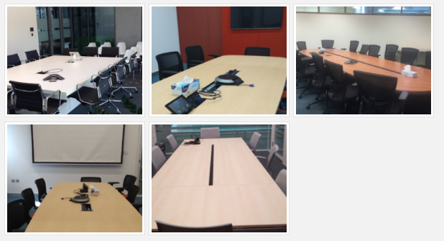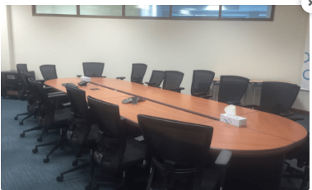
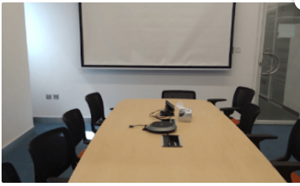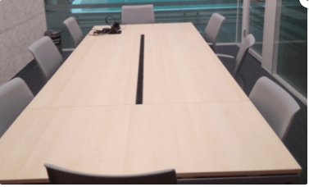

Appendix 3
Description | Category | Date Submitted | Date Submitted
Sports | Sports Hall | 13:52 | 23rd May 2023
Consultancy | Petroleum Engineering | 13:54 | 23rd May 2023
Laboratory Rental | Civil Engineering Labs | 13:55 | 23rd May 2023
Venue Rental | Computer Labs | 13:58 | 23rd May 2023
Email to BD Department |  | 10:33 | 26th May 2023

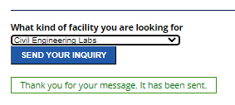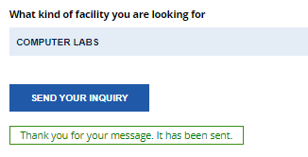
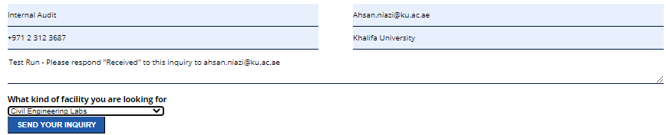
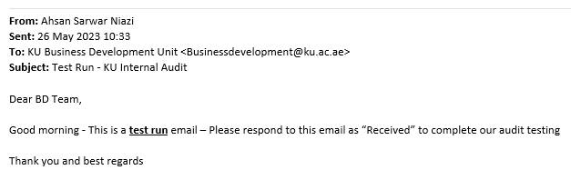
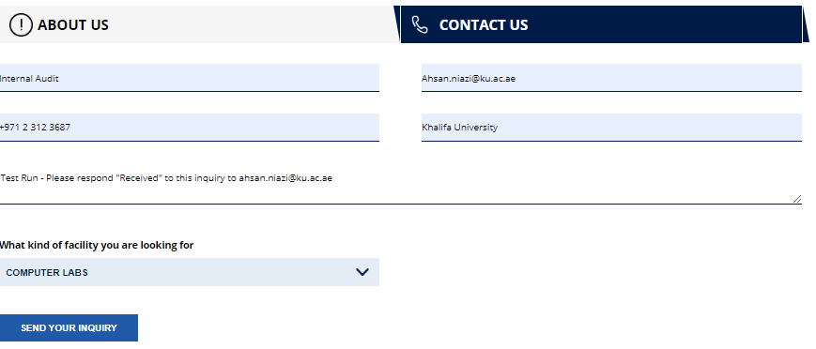

Appendix 4
BD Presentation 2022
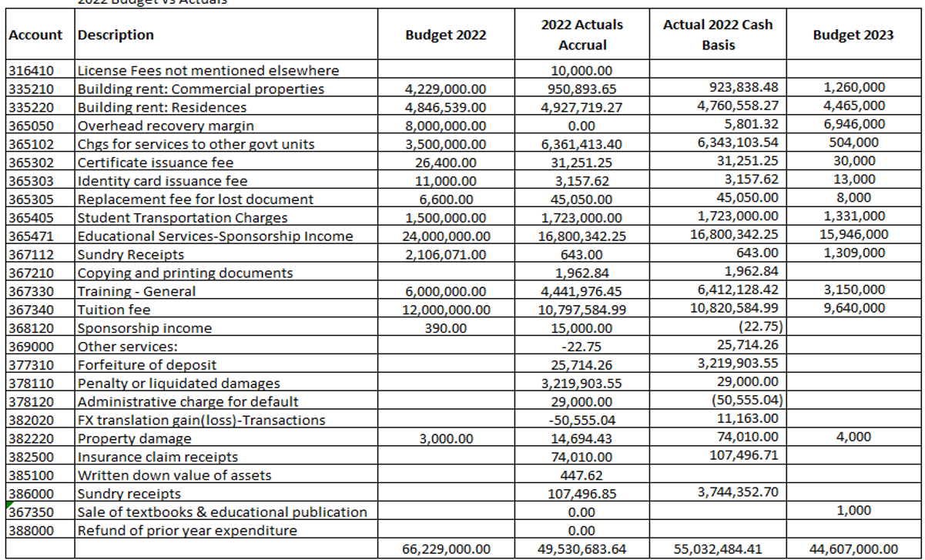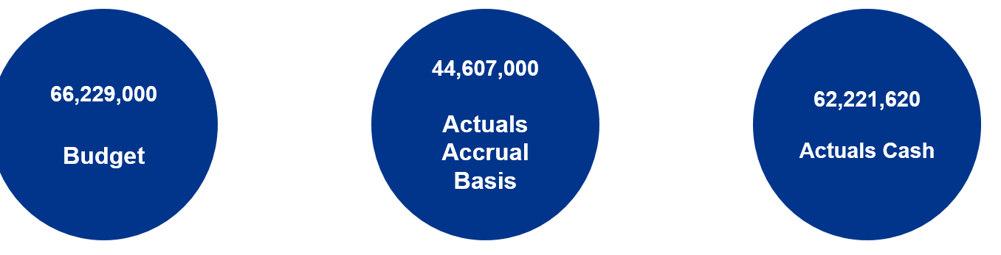

Revenue Q1 2023 Presentation

